**Semestral Project - Enterprise Informatics 2**

**PALACHOVY-TECHCLOUD**



Jesús Calleja Rodríguez

Manuel Muñoz Marín

Jose Luis Pedraza Roman

Taner Beyhan

***Enterprise description***



**-Goals**

Offering a server rental service internationally oriented from personal use to professional use providing different specialized services in a series of packages.

**-Customers**

Our company tries to supply the needs of all types of customers by dividing its product offer into three different packages, which are the following:  
Basic-Cloud-> Oriented for personal use  
Pro-Cloud-> Oriented to professional use for huge companies  
G-Cloud-> Oriented to professional video game players

**-Business Strategy**

Seeking potential customers and create different customized packages with different services according to the user needs.

**-Finance statements**

Initially, we made a capital investment for infrastructure and human resources. Currently, our funding is based on the rental of service packages and donations that our partners contribute to our company.  
We also have different agreements with different organizations in the education, government and business sectors.

**-Difficulties**

Our main concern is to be able to supply our customers at all times, so we must always be prepared to solve problems ranging from connectivity to the security of our users' data.  
To guarantee the quality of our service, our team is continuously working on the maintenance of the system.

* ***IT Governance Arrangement Matrix***

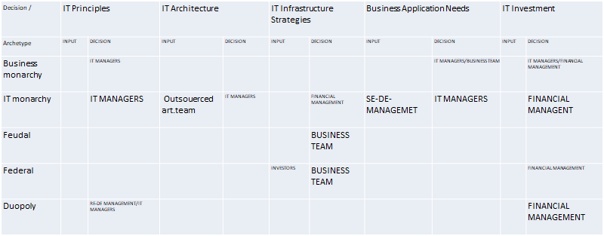

* ***IT Governance questionnaire***

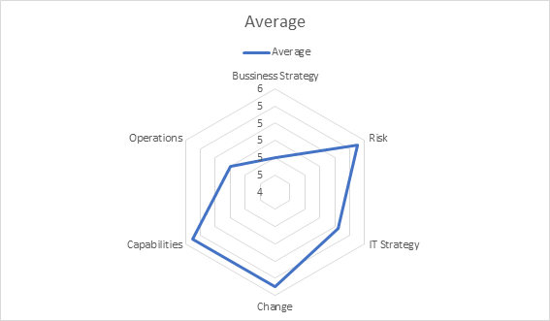

***Business Strategy***

**Question 3:** IT experts are a great support for leaders but they do not play an important role in our business strategy.

**Question 7:**  We do not always use simple software since some tasks require more complex software.

**Question 2:** Our vision of the project is constantly changing and that is why we are going to be pioneers in different areas, attracting different clients.

In conclusion, although there is apparently a deficit in the value of the business strategy graph, this is compensated with good results in the field of changes in our chart

***Risk***

**Question 10 and Question 15:** Because our directors know perfectly the impacts of IT Governance on the work and personnel of the company, we obtain a correct management of strategies and our intellectual capital.

***INVESTMENT PORTFOLIO***

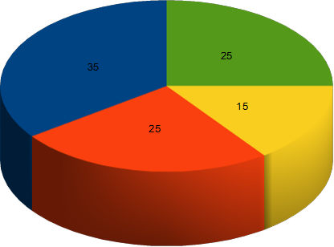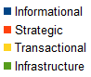

***Informational***

As a beginning, our company provides an incredible cloud computing system, which is related to rent services, as well as creating the idea of the informatical service so that’s why we decided to select that high percentage for Informational.

***Strategic***

We assumed that our company doesn’t have the big capacity of service hence we cannot even provide a big service. For this reason, we usually would like to increase the capacity of the system effectively. In addition, we decided to create 25% in the graph.

***Transactional***

An example of reducing the cost of services mostly we buy hardware from external companies. In other words in order to provide an incredible way we have to stand our expenses ambitiously. For this purpose, we need to create 15% in the graph.

***Infrastructure***

As a beginning, we would like to think the whole service entirely. In other words, it’s vital that we should focus on creating the system altogether, that’s why we selected 25% in the graph.

***RESULTS CHAIN***

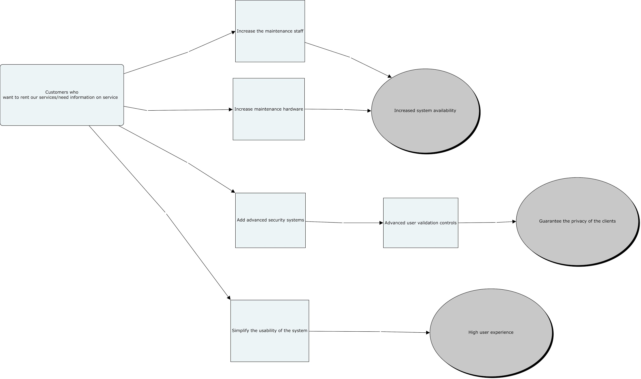

***PROCESS EVALUATION USING MATURITY MODELS***

*Level 0 - Initial*

Lack of a stable environment for implementation our goals should be a focus on keep privacy of people safely if the system is down, our employers should carry on working hard to ensure continuous availability.

*Level A - Repeatable*

The measure of attempting this way is to provide the service continuously, also for the customers obtain gathering information from our company, in other words, we are not able to find new customers for our company, that's why we usually attempt to repeat the information.

*Level B - Defined*

Our company involves the implementation of the system somehow, also we are aware of providing an idea which will able to help the customers. For this reason, it is obvious that aware of the problem definition.

*Level C - Managed*

We have an infrastructure made by all our partners and investors because all the decisions can’t be taken by only one person that’s why we shared the information with our entire investors.

*Level D - Optimizing*

In order to provide service ambitiously, our company usually follow the trends of technology, to be the first company where the sector is.

***SERVICE DESK IMPLEMENTATION***

We will integrate the service desk being in contact constantly with our customers and all the people or organizations that are gonna use our services. Inside our service desk, we integrate help desk too, because it’s something similar but not the same in consideration of knowing that we used to call help desk to service desk before, but this concept is longer.

So, we will have a channel for communication between our technicians and the users for answering all kinds of questions and trying to help the customers.

In our service desk we will allow a good integration of our employees, also, we will provide courses to understand how the system works.

We’ll facilitate access to all the data of our company to the employees for allowing them to know all the new implementations and improvements in the organization.

We are going to do reports monthly of all the modifications in our company to permit all the people being informed about it.

On the other hand, we will have an easy way to incorporate new suppliers and new partners as well we’ll allow them to abandon the organization without difficulties if they want.

***ESTABLISHING HELPDESK***

In the most of days, We had been struggling with getting knowledge from helpdesk which can be helped our stuff such as copy center, working with IT department, relating to access login page on our website.

As a beginning, in order to establish the help desk that definitely needs many things such as hiring people who will be working at the help desk. In our company, we usually divide to duties effectively as well as providing the technical systems in our IT department need people who definitely have a role in the helpdesk. For instance in this department will be 2 people who will be responsible for intangible stuff that can be technical things such as accessing the system or renew the passwords on our system in order to clarity effectively. On the other hand, only one person can manage the department hence we do not want to invest a sum of money on it. And the rest of them will be responsible for concrete things that can be copied center, providing tools such as a keyboard, mouse and so on.

***SLA preparation***

SLA preparation is a way to provide a service between customers and the company. Also, in this section, we should focus on the definition of the problem such as customer needs.

**Service hours**  
Service must be available from 9:00 AM to 10:00 PM, Monday through Friday, except when the Customer facilities are closed due to bank holidays, administrative closings, or inclement weather. A service can be requested or an Incident reported via telephone during working hours, or by mail or by the Web Service Portal at any time.

**Service avability**

For the provision of the Service covered by this SLA, availability is determined by the percent of the time components of the Service are available to users. IT workers will seek 100 % availability during working hours for all the interfaces combined (telephone, e-mail or Web) to report or request, that means client will always have at least one mean available to report and Incident or request a service at working times. Availability of each interface alone is provided below:

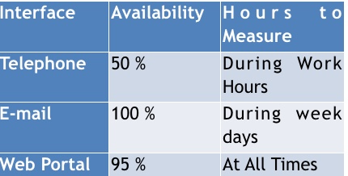

**Service Reliability**

As a part of quality of service, All workers should be arrange a meeting in order to discuss it.On the other hand, based on mission one customer equals value for the company.To measure the value of reliability, we should focus on the feedback from the customer.  
The following questions can be asked to the customers after the business has done;  
1-Did we really solve the problem which were able to solve ?  
2-What can you say about the company?Did you satisfy?  
  
**Service Performance**

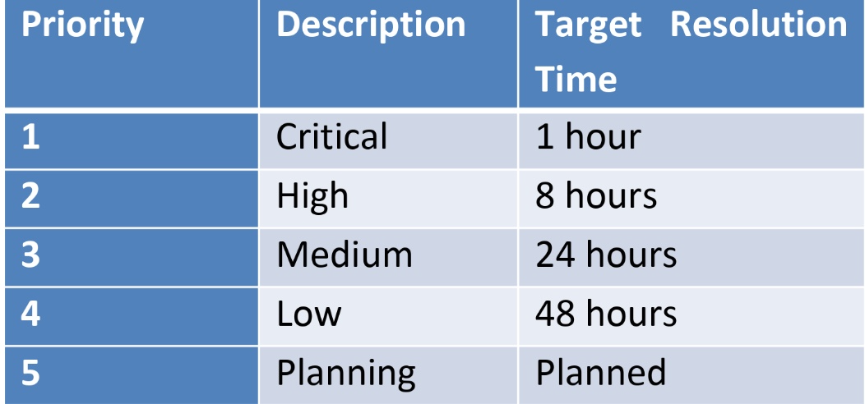  
  
**Determination of Priorities**

